Adding Maths Hub Administrators and Leads:
A Maths Hub Administrator who needs access to MHPOD needs to be added in 3 places. After you have checked if they have a ‘Person’ record by name/email search you need to:
- Add them as a Person
MHPOD > Administration > People > Search for the user then Add them > remove any spaces after their email address > Save
Any duplication error will imply they may already be in the system with the same email address or NCETM Username. Before saving, search for them again before potentially adding a duplicate.
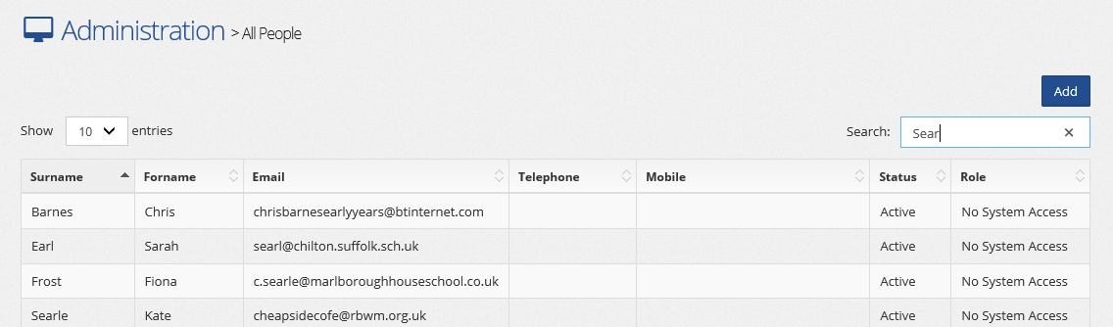
- Add them to the correct Hub.
MHPOD > Administration > Hubs > Select Hub > Hub Roles > Add the person and Role ‘Hub Admin’ and Role Description if known > Save
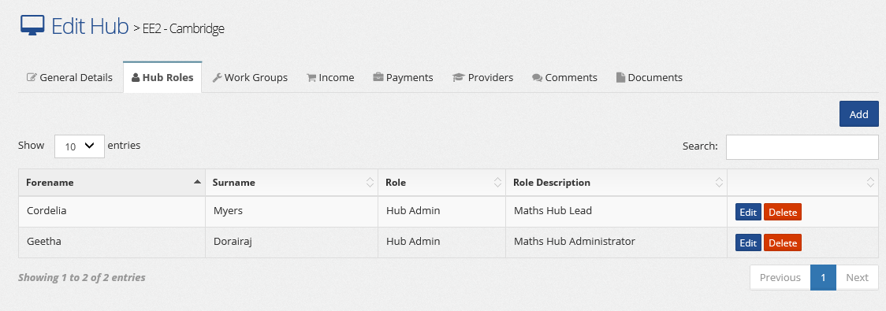

- Add them to the Accounts to issue them a password to get into MHPOD
MHPOD > System Administration > Search for the Person you just set up > Add them (making sure they are ‘Hub Admin and Active) > Press Password Reset

